Regrade Request form

Class: CS5800 Algorithms

Name:

Saleh Alkhalifa

Date:

10/2/2022

Assignment associated with Request:

Module 2: Homework Assignment

Problem #s associated with Request:

#3 and #4

Reason for Regrade Request. Note, you must provide at least a paragraph, for EACH Problem, to explain your reason for a regrade on the associated problem. This explanation must include specific evidence as to what you believe to be incorrect about the current grade. Drawings are also acceptable to support your argument

Problem #3

The TA specified that I explained RSA and not Diffie-Hellman. I sent a comment on Canvas letting the TA know that I explained both concepts here to show the difference between the two. I wanted to illustrate that Diffie-Hellman generates a public and private key on both sides, but only shares the public key, whereas RSA is used for digital signatures and does require the exchange of the public key ahead of time. I attached screen shots directly from my homework assignment below.

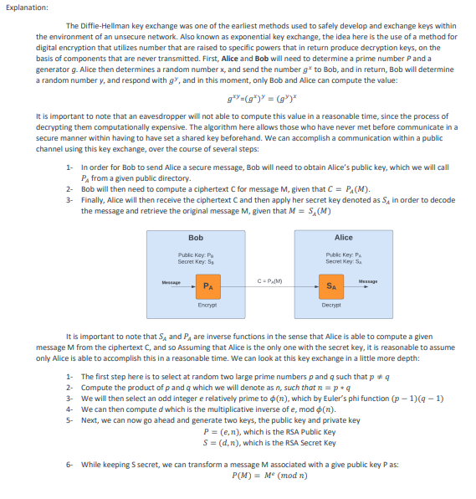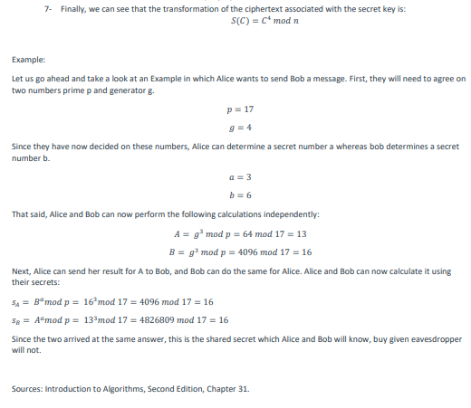

Problem #4:

The TA specified that I failed to submit one of the two screen shots showing the two examples. In reality, I had included only one screen shot that had both examples in it. I attached screen shots directly from my homework assignment below. In the image below, you will see two arrays with two thresholds being used, per the specification in the homework assignment. In addition, I also created a custom set of functions to automatically iterate over the given input file and output the results of each, going above the beyond the requirements.

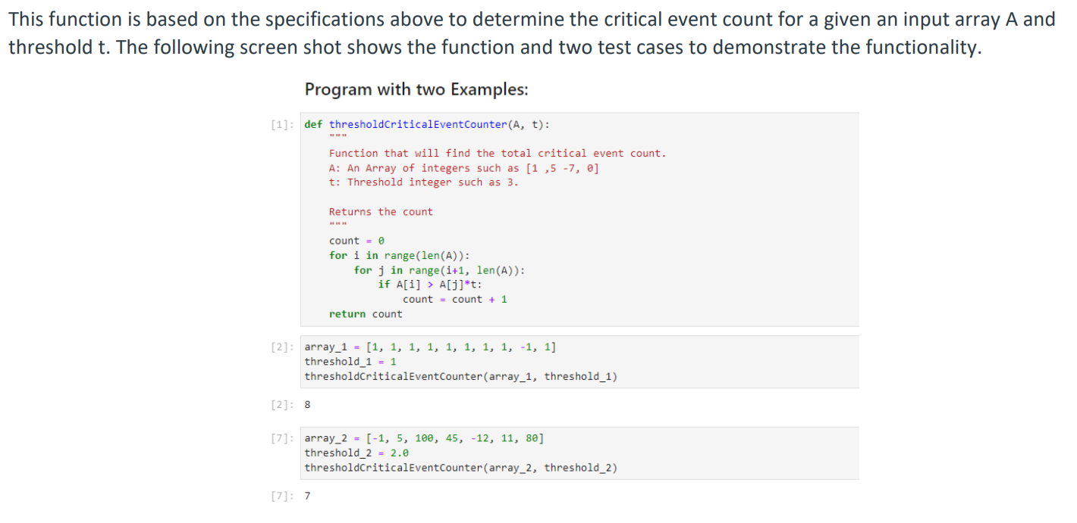

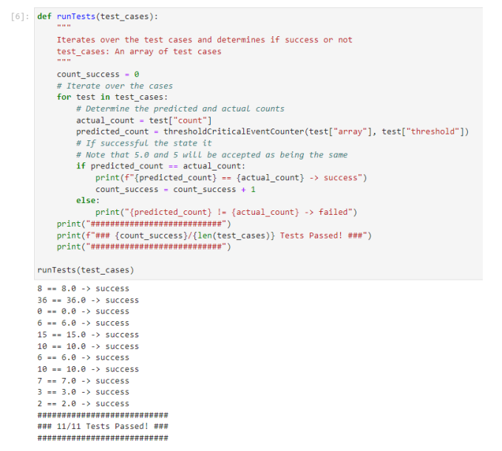

Please note: If a regrade is approved, a regrading means the original grade for the entire problem will be discounted, and the result of the regrade will be used instead. There is no reclamation of the original grade, so the regrade has the potential to be lower or higher than the original grade.

Please send regrade requests to [j.kennedy@northeastern.edu](mailto:j.kennedy@northeastern.edu)